

**National College of Computer Studies**

Paknajol, Kathmandu

**Report on Quiz Management System**

Submitted by: Baivab Bhusal Submitted to:

Programme: BSc. CSIT, 4th Semester Sumit Ghising

Roll No: 06 Section:A Java Tutor

Email: [baivabbhusal229@gmail.com](mailto:baivabbhusal229@gmail.com)

# ACKNOWLEDGEMENT

This report is my assignment as a partial fulfillment of project work course for the requirement of Bachelor of Science in Computer Science and Information Technology (Bsc.CSIT). Before getting into thick of things, I would like to add few words of appreciation for the people who have been a part of this project right from its inception. The writing of this project has been of the significant academic challenges I have faced and without the support, patience and guidance of the people involved, this task wouldn’t have been completed. It is to them we own our deepest gratitude.

It gives me immense pleasure in presenting this project report on “QuizFest”. The success of this project is a result of this hard work and determination put in by us with the help of my project guide. I hereby take this opportunity to add a special note of thanks for Mr.Sumit Ghising sir, who undertook at act as our mentor despite her many other academic commitments. Without his insight support and energy wouldn’t have started and neither have reached fruitfulness.

Also, our deepest appreciation especially to our other teachers for their utmost support and encouragement without them all these would not be possible. Last but not the least, many thanks and appreciation to all our colleagues for helping us with a lot of ideas, motivations and encouragements.

Table of Contents

ACKNOWLEDGEMENT i

ABSTRACT iii

Chapter-1 1

Introduction: 1

1.1 Introduction to Quiz Management System 1

1.1 Objective of the project 1

1.3 Features of the Quiz Management System: 2

1.4 Potential Problems of the Quiz Management System: 3

1.5 Future Enhancements for the Quiz Management System 4

Chapter-2 5

Implementation 5

2.1 The Hardware used 5

2.2 The Software used 5

2.3 Classes in the Quiz Management System 6

Chapter-3 6

Output 6

Conclusion 10

References 11

# ABSTRACT

The Quiz Game Project is an interactive app created to improve learning in an entertaining way. By using gamification principles, this project encourages users to engage by offering an exciting educational experience. Developed with modern programming languages and technologies, the game ensures a reliable and user-friendly interface.

The main goal of the Quiz Game Project is to promote learning through a competitive and enjoyable approach. Users can choose from a variety of categories such as science, history, literature, and more, customizing the experience to their interests and educational goals. Each quiz session includes multiple-choice questions, true/false statements, and timed challenges to assess users' knowledge and response time. Key elements of the Quiz Game Project include a scoring system that monitors user progress and delivers immediate feedback to reinforce learning. Additionally, the game offers both single-player and multiplayer modes, supporting individual study and collaborative competition. Leaderboards and achievement badges are included to inspire a sense of achievement and encourage ongoing participation.

***Keywords:*** *technology,score,game,quiz,question*

# Chapter-1

# Introduction:

## 1.1 Introduction to Quiz Management System

The Quiz Management System is a Java-based console application designed to streamline the process of administering and attempting quizzes. It offers distinct functionalities for two user roles: **Admins** and **Users**, ensuring a clear separation of responsibilities and features. By leveraging a MySQL database, the system provides secure storage and retrieval of user and quiz-related data. There are a lot of quiz applications available on the internet right now. However, a few facilitate improved comprehension between users and the application, such as by offering appropriate responses, resolving user queries, allowing users to submit inquiries and receive responses, etc. The project's goal is to eliminate the manual system's time-consuming drawbacks. Additionally, this application will verify the correct response, save the examiner time, and conduct the examination in an efficient manner. The existing system wastes the examiners' time when they review the answer sheets after the test. The system will alert users when they enter incorrect data, thus users do not require advanced computer skills to utilize it. This initiative aims to computerize the current manual procedure and assist examiners in saving critical data and valuable time. In addition, the data stored in this system will be readily available and persist for a considerable amount of time.

## 1.1 Objective of the project

The aim of the "Quiz Game" is to provide a convenient and effortless experience for all users while eliminating the need for manual labor. In previous times, quizzes were conducted through manual means, but with the advancement of technology, we now have the ability to automatically generate scores and present questions. The practical necessities encompass generating user profiles for quiz participation and automated score and report production.

• **Simplify Quiz Management**:  
Provide an efficient and user-friendly interface for admins to manage quiz questions, including adding, updating, deleting, and viewing questions.

• **Streamline User Registration and Authentication**:  
Implement a secure registration and login system for users and admins, ensuring data privacy and preventing unauthorized access.

• **Enable Role-Specific Functionality**:   
Separate functionalities for admins (quiz management) and users (quiz participation), creating a clear distinction between roles.

• **Enhance Data Security and Persistence**:  
Use a MySQL database to securely store user details and quiz questions, ensuring data integrity and availability.

## 1.3 Features of the Quiz Management System:

**Admin Features:**

****Admin Login:****

Secure authentication system for admin access to quiz management features.

****Question Management:****

Add new questions with multiple-choice options and correct answers.

Update existing questions, including the question text, options, and correct answers.

Delete questions from the database.

View all stored questions with their details for verification and updates.

****User Features:****

**1.User Registration:**  
 Users can register by providing details such as first name, last name, username, email, and password.

**2.User Login:**  
 Secure login system for users to access the quiz section.

****3.Quiz Attempt:****

Users can attempt quizzes by answering multiple-choice questions.

Quiz questions are randomly selected to provide a dynamic experience

**General Features:**

**Role-Based Navigation:**  
Separate sections for admin and user functionality, with clearly defined roles.

**Database Integration:**

All user and quiz data is stored in a MySQL database.

Efficient CRUD operations ensure smooth data handling.

**Scalability:**  
The system is designed to be extendable, allowing future additions such as advanced scoring, analytics, or quiz categories.

**User-Friendly Interface:**  
Intuitive and menu-driven console interface for seamless navigation and usability.

## 1.4 Potential Problems of the Quiz Management System:

****1. Limited User Interface:****

The system uses a console-based interface, which might not be visually appealing or user-friendly for non-technical users.

No graphical user interface (GUI) could reduce its accessibility and usability.

****2.Absence of Advanced Features:****

No ability for admins to view quiz analytics, such as the most attempted or difficult questions.

Users cannot save progress or resume quizzes later.

No mechanism for awarding certificates or badges based on quiz performance.

****3. Platform Dependency:****

The system is currently designed for MySQL and a Java console environment, making it less flexible for deployment on other platforms without modification.

****4.Security Issues:****

Passwords are stored in plaintext in the database, making them vulnerable to unauthorized access or data breaches.

No encryption or hashing mechanism is used for sensitive user data.

Lack of measures to prevent SQL injection attacks could lead to database vulnerabilities.

## ****1.5 Future Enhancements for the Quiz Management System****

To improve the functionality, user experience, and scalability of the system, the following enhancements can be considered:

1. **User Experience Enhancements**

**Web-Based Interface:**

* Develop a web-based front-end using frameworks like React, Angular, or Vue.js for better accessibility.
* Alternatively, create a mobile app for Android and iOS platforms.

**Timer for Quizzes:**

* Introduce a timer feature to make quizzes more competitive and time-bound.
* **Multi-Language Support:**
* Add support for multiple languages to cater to a diverse user base.

1. **Security Improvements**

**Password Encryption:**

* Use hashing algorithms like bcrypt or SHA-256 to store user passwords securely in the database.
* **Role-Based Access Control:**
* Implement more granular roles (e.g., Super Admin, Moderator, Basic User) with specific permissions.

**Two-Factor Authentication (2FA):**

* Add an extra layer of security during login by integrating OTPs or email verification.

**3. Admin-Specific Enhancements**

**Question Import/Export:**

* Enable admins to upload questions in bulk using CSV or Excel files.
* Provide the option to export all questions for backup or transfer purposes.

**Quiz Analytics:**

* Add dashboards to analyze user performance, most difficult questions, and frequently attempted quizzes.

**Question Categories:**

* Allow admins to categorize questions by subject or difficulty level (e.g., Math, Science, Beginner, Advanced).

**4. User-Specific Enhancements**

**Performance Tracking:**

* Provide users with detailed reports of their quiz history and performance trends over time.

**Leaderboard:**

* Create leaderboards to display top scorers for a specific time frame (e.g., daily, weekly, monthly).

**Retry Options:**

* Allow users to retry quizzes with feedback on incorrect answers.

# Chapter-2

# Implementation

## 2.1 The Hardware used

The implementation of Quiz Management system using java can be done on any hardware that supports the java programming language, including personal computers, laptops, and servers.

## 2.2 The Software used

The software used to develop this program is IntelliJ IDEA and its frameworks. There is no graphics used. Some popular java IDEs include Visual Studio, VS code, Netbeans and Eclipse.

## 2.3 Classes in the Quiz Management System

**Admin Class**

Purpose:

Handles admin-specific tasks such as user registration, login, and quiz question management.

Key Methods:

* registration(Scanner sc): Handles user registration and saves details to the database.
* saveToDatabase(String fName, String lName, String userName, String email, String userPassword): Saves user details to the database.
* login(Scanner sc): Authenticates admin login by checking credentials in the database.
* manageQuestions(Scanner sc): Manages operations related to quiz questions (add, update, delete, view).
* addQuestion(Scanner sc): Adds a new quiz question to the database.
* updateQuestion(Scanner sc): Updates an existing quiz question.
* deleteQuestion(Scanner sc): Deletes a question from the database.
* viewQuestions(): Displays all the quiz questions stored in the database.

****Users Class****

Purpose:

Handles user-specific functionality, such as attempting quizzes.

Key Methods :

attemptQuiz(Scanner sc): Allows users to take quizzes by fetching questions from the database.

# Chapter-3

# Output

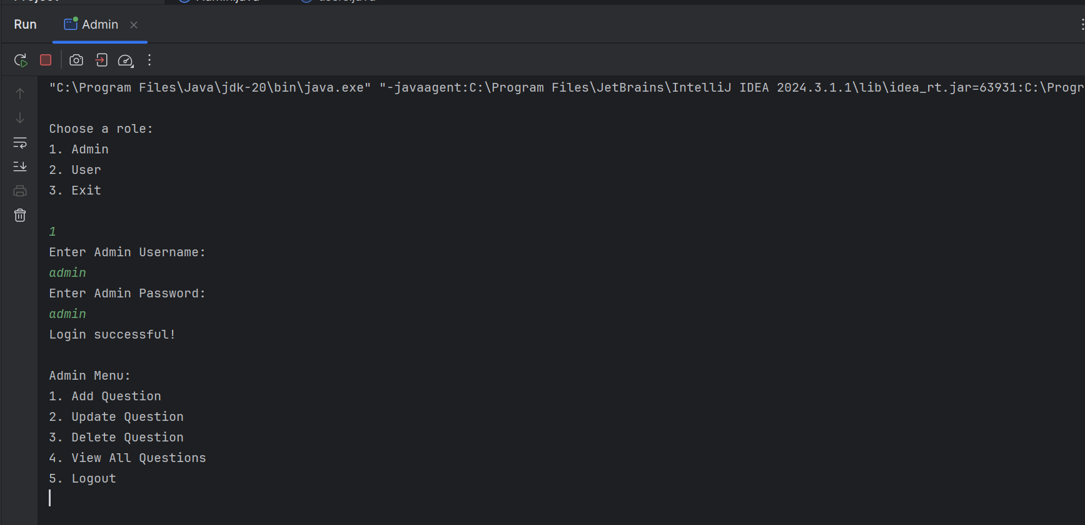

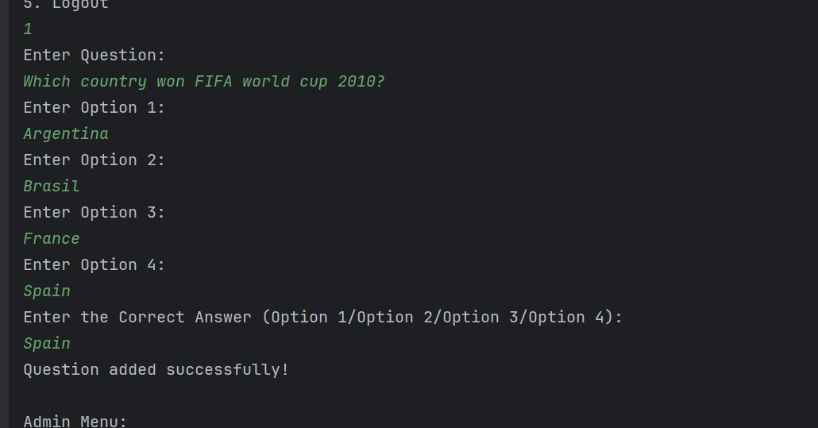



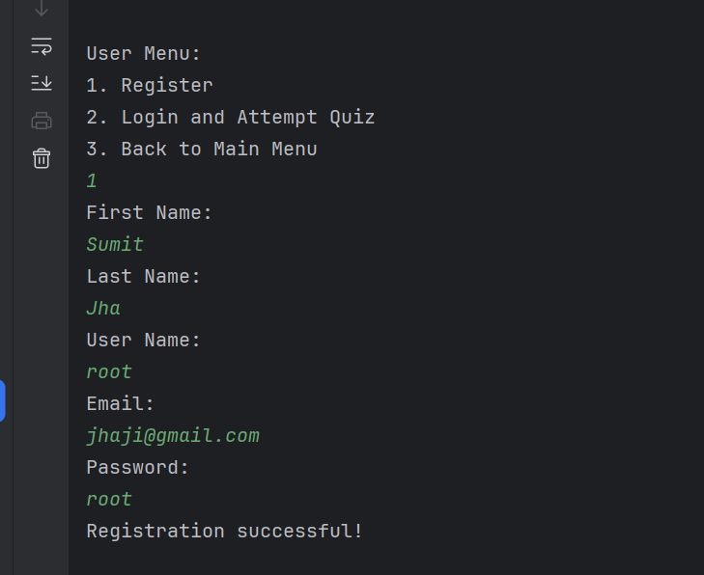

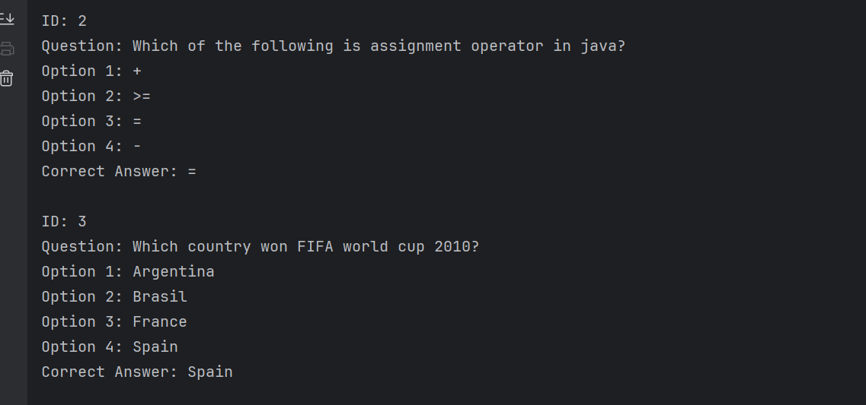

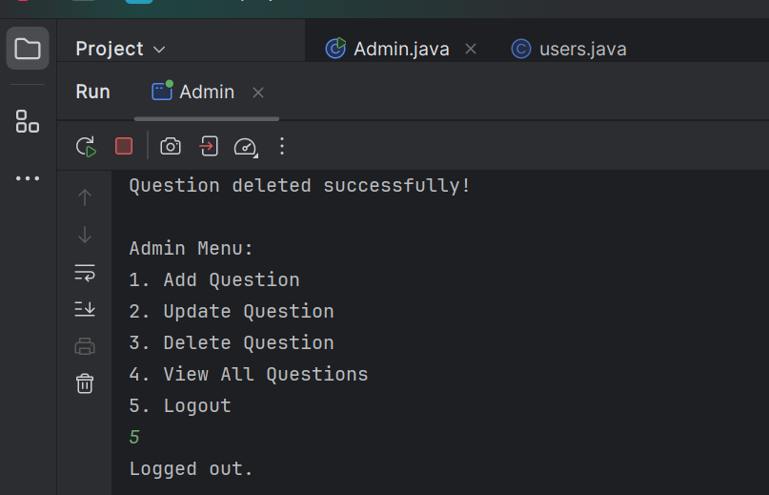

# Conclusion

The Quiz Management System is a basic yet functional application designed for user registration, admin management, and quiz participation. It effectively demonstrates the use of Java, JDBC, and MySQL to create an interactive console-based system. While it provides core features like user registration, login, question management, and quiz attempts, the project has limitations in terms of user interface, security, scalability, and advanced functionality. Addressing these challenges in future iterations would enhance its usability, security, and overall performance, making it a more robust and practical solution for quiz management.

# References

[1] <https://www.techtarget.com/searchwindowsserver/definition/java>

|  |  |
| --- | --- |
| [3] | J. Sidar, "Quiz Game Documentation," 22 January 2019. [Online]. Available: https://www.scribd.com/document/397989318/Quiz-Game-Documentation. [Accessed 18 May 2024]. |
| [4] | zccindia, "SlideShare," 13 June 2022. [Online]. Available: https://www.slideshare.net/slideshow/quiz-game-project-reportpdf/251974213. [Accessed 18 May 2024]. |
| [3] | "GeeksforGeeks," 16 October 2023. [Online]. Available: https://www.geeksforgeeks.org/quiz-game-in-c-2/. [Accessed 18 May 2024]. |

[2] Tutorials point. (n.d.). Retrieved 1 2, 2025, from [www.tutorialspoint.com](http://www.tutorialspoint.com)